

Real-time Stock Market Analytics Through Efficient Data Warehousing and Predictive Models

A CAPSTONE PROJECT REPORT

A Capstone Project Report submitted in partial fulfilment of the requirements for the Course of

CSA1610 – DATA WAREHOUSING AND DATA MINING

to the award of the degree of

BACHELOR OF ENGINEERING / BACHELOR OF TECHNOLOGY IN
COMPUTER SCIENCE AND ENGINEERING
(ARTIFICIAL INTELLIGENCE)

Submitted by
A. Dileep kumar[192372074]
D. Deepak[192572095]

Under the Supervision of
Dr K V Kanimozhi
SIMATS ENGINEERING
Saveetha Institute of Medical and Technical Sciences Chennai-602105

SEPTEMBER 2026

SIMATS ENGINEERING
Saveetha Institute of Medical and Technical Sciences Chennai-602105

BONAFIDE CERTIFICATE

This is to certify that the Capstone Project entitled “Real-time Stock Market Analytics Through Efficient Data Warehousing and Predictive Models” has been carried out by D.Deepak (192572095) and A.Dileep kumar (192372074) under the supervision of Dr. K V Kanimozhi and is submitted in partial fulfilment of the requirements for the current semester of the B.E. Computer Science and Engineering program at Saveetha Institute of Medical and Technical Sciences, Chennai.

COURSE COORDINATOR COURSE FACULTY
Title / Name, Title / Name,
Designation Designation
Branch / Department Name Branch / Department Name
SIMATS Engineering, SIMATS Engineering,
SIMATS, Chennai – 602105. SIMATS, Chennai – 602105.

SIMATS ENGINEERING
Saveetha Institute of Medical and Technical Sciences Chennai-602105

DECLARATION

I, D.Deepak, A.Dileep kumar of the CSE(Artificial Intelligence), SIMATS Engineering, Saveetha Institute of Medical and Technical Sciences, Chennai, hereby declare that the Capstone Project Work entitled “Real-time Stock Market Analytics Through Efficient Data Warehousing and predictive models” is the result of our own Bonafide efforts. To the best of our knowledge, the work presented herein is original, accurate, and has been carried out in accordance with the principles of engineering ethics and academic integrity. All sources, references, data, and other materials used in the project have been appropriately acknowledged. We further declare that the data, results, analysis, and findings presented in this report have not been fabricated, falsified, or manipulated. Any external tools, software, datasets, computational resources, or AI-assisted tools used during the project have been appropriately disclosed. We confirm that all applicable ethical, academic, institutional, and professional requirements have been duly followed throughout the planning, execution, analysis, and documentation of the project.

Place: Thandalam, Chennai
Date:

Signature of the Students with Names
A. Dileep kumar(192372074)
D. Deepak(192572095)

SIMATS ENGINEERING
Saveetha Institute of Medical and Technical Sciences Chennai-602105

Individual Contribution Statement

Student Name / Register No. | Specific Responsibilities | Design & Development Contribution | Testing & Analysis Contribution | Report Contribution | Approx. Contribution (%)
D Deepak | Data warehouse design, preprocessing pipeline | Stock schema, ETL, feature engineering | Time-aware validation and analysis | Ch. 1–3 | 50%
A Dileep Kumar | Model implementation, evaluation | Predictive models and dashboard outputs | Metrics and model comparison | Ch. 4–5 | 50%

ABSTRACT

Stock markets generate large volumes of time-dependent data through daily trading activity, including opening price, high price, low price, closing price, traded volume, and derived market indicators. Analysing these data efficiently requires an organized data warehouse that can integrate historical market records, prepare them for analytics, and support predictive models for short-term market movement.

This project presents a data-driven stock market analytics framework that combines efficient data warehousing with predictive modelling. The proposed pipeline collects historical stock records, performs data cleaning and transformation, stores the analytical data in a structured warehouse, and derives indicators such as moving averages, daily returns, volatility, and volume changes. The warehouse is designed to support fast historical analysis across stock, date, and market dimensions.

Predictive modelling is used to estimate the next-period market movement from historical price and volume behaviour. The implementation compares multiple supervised learning approaches and evaluates them using suitable regression or classification measures, depending on the prediction target. Feature importance and error analysis are also used to identify the market variables that contribute most strongly to predictive performance. The framework is intended as an analytics and decision-support prototype rather than a guaranteed trading system.
The resulting architecture demonstrates how a well-designed warehouse can separate data ingestion and preparation from analytical and predictive workloads. This improves data consistency, supports historical trend analysis, reduces repeated preprocessing, and provides a scalable foundation for real-time stock market analytics when live data feeds are connected in future work.

Keywords: Stock Market Analytics, Data Warehousing, Data Mining, Predictive Models, Time-Series Data, ETL, Market Trend Prediction, Financial Analytics

TABLE OF CONTENTS
Sl. No | Title | Page No
i | CERTIFICATE FROM THE SUPERVISOR | 2
ii | DECLARATION BY THE CANDIDATE | 3
iii | INDIVIDUAL CONTRIBUTION STATEMENT | 4
iv | ABSTRACT | 5
v | LIST OF FIGURES | 7
vi | LIST OF TABLES | 8
vii | LIST OF ABBREVIATIONS | 9
1 | CHAPTER 1: Introduction | 10
2 | CHAPTER 2: Literature Review | 13
3 | CHAPTER 3: Engineering Design & Trade-offs, Sustainability, Ethics, Safety, Risk & Security | 15
4 | CHAPTER 4: Implementation, Testing & Results, Project Management | 20
5 | CHAPTER 5: Conclusion & Reflection | 27
 | References | 29
 | Appendices | 30

LIST OF FIGURES
Figure No. | Figure Name | Page No.
1.1 | Overall Stock Market Analytics System Architecture | -
4.1 | Stock Price and Market-Movement Distribution | -
4.2 | Correlation Heatmap of Market Features | -
4.3 | Confusion Matrix — Predictive Model | -
4.4 | Model Comparison — Prediction Performance | -

LIST OF TABLES
Table No. | Table Name | Page No.
3.1 | Stakeholder & Functional/Non-Functional Requirements | -
3.4 | Alternative Solutions Evaluation Matrix | -
3.6 | Trade-off Analysis | -
3.7 | Sustainability, Ethics, Safety, Security & Risk Register | -
4.4 | Descriptive Statistics of Stock-Market Features | -
4.6 | Objective Achievement Mapping | -

LIST OF ABBREVIATIONS / SYMBOLS
Symbol | Description | Unit
OHLCV | Open, High, Low, Close, Volume | -
ETL | Extract, Transform, Load | -
DWDM | Data Warehousing and Data Mining | -
ML | Machine Learning | -
RF | Random Forest | -
SMA | Simple Moving Average | -

CHAPTER 1

INTRODUCTION AND ENGINEERING PROBLEM

1.1 Background
Financial markets produce continuously changing datasets containing prices, trading volume, timestamps, company identifiers, and market indicators. Raw market data is commonly obtained from different files, APIs, exchanges, or data providers and may contain missing values, duplicate records, inconsistent timestamps, and different formats. A data warehouse provides a centralized analytical structure in which these heterogeneous records can be cleaned, integrated, and organized for efficient querying. Data mining and predictive modelling can then be applied to the warehouse to discover trends and estimate future market behaviour from historical observations.

1.2 Need for the Project
- Stock market datasets can become large and difficult to analyse when historical observations are stored as unstructured or independent files.
- Repeated calculations of returns, moving averages, volatility, and volume-based indicators increase processing time when the raw data is not organized for analytical workloads.
- Market data may contain missing observations, duplicate timestamps, inconsistent symbols, and different date or price formats, making preprocessing an important engineering requirement.
- An integrated warehouse and predictive analytics pipeline can provide a consistent historical view of market behaviour while supporting faster analytical queries and repeatable model training.

1.3 Problem Statement
Given historical stock market data containing time, stock identifiers, OHLC prices, traded volume, and derived indicators, design and implement an efficient data warehouse and predictive analytics framework that can clean and integrate the data, support analytical queries, identify important market patterns, and predict a defined next-period market outcome while maintaining acceptable processing performance and data quality.

1.4 Project Aim
To design and implement a real-time-oriented stock market analytics framework that uses efficient data warehousing and predictive models to organize historical market data, generate analytical indicators, and support short-term market movement prediction.

1.5 Project Objectives
- To design a dimensional data warehouse schema for integrating stock, market, and time-based trading records.
- To develop an ETL and preprocessing pipeline for duplicate removal, missing-value handling, timestamp standardization, and feature generation.
- To generate analytical indicators such as daily return, moving averages, volatility, price range, and volume-based measures.
- To implement and compare multiple predictive models for next-period stock movement or price-related prediction.
- To evaluate predictive performance using appropriate accuracy, precision, recall, F1-score, MAE, RMSE, or related measures according to the selected target.
- To demonstrate how the warehouse supports efficient historical analysis and can be extended toward real-time market monitoring.

1.6 Scope
Included: structured stock market data containing date/time, ticker or stock identifier, open, high, low, close, adjusted close where available, trading volume, and derived technical indicators; historical analytics and short-horizon prediction are the primary focus.
Excluded: guaranteed investment advice, automated order execution, brokerage integration, manipulation of live exchange systems, and claims that predictions can eliminate market risk.
Assumptions: source market records are obtained from an authorized dataset or API, timestamps are normalized to a common convention, and the prediction target is defined before model training to prevent data leakage. The analytical warehouse stores transformed records separately from the raw ingestion layer.
Boundary condition: stock prices are influenced by many external factors, including news, macroeconomic events, liquidity, and investor behaviour. Therefore, the prototype evaluates predictive patterns in the available dataset and does not represent its predictions as certain future outcomes.

1.7 Expected Engineering Outcome
A working stock market analytics prototype consisting of a structured warehouse schema, ETL pipeline, feature-engineering layer, predictive modelling component, analytical visualizations, and evaluation report. The design should be suitable for extension from batch historical data toward streaming or near-real-time ingestion.
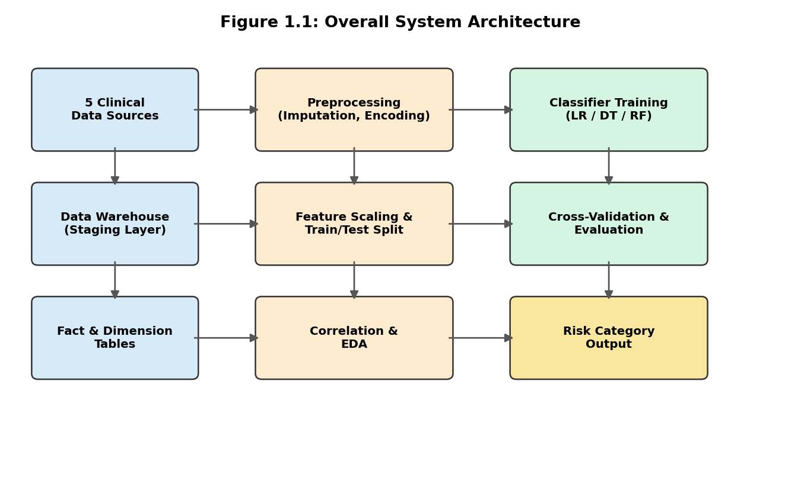
Figure 1.1: Overall System Architecture — market data sources flow through ingestion and staging, warehouse transformation and storage, feature engineering, predictive modelling, and analytics dashboards to produce market insights and next-period predictions.

CHAPTER 2

LITERATURE REVIEW AND EXISTING SOLUTIONS

2.1 Review Method
Literature was reviewed across financial time-series analysis, stock market prediction, data warehousing, ETL architectures, technical indicators, and machine learning for financial analytics. The review focuses on how structured historical market data can be transformed into reliable analytical features and used in predictive systems while reducing data leakage and maintaining computational efficiency.

2.2 Review of Existing Work
- Traditional market analysis commonly uses price and volume indicators such as moving averages, rate of return, volatility, momentum, and price ranges. These methods are easy to interpret and are useful for descriptive and exploratory analytics, but they do not always capture nonlinear relationships between multiple market variables.
- Machine-learning studies use supervised learning methods to classify future price direction or estimate future price-related values from historical observations and engineered indicators. Model selection depends on the target definition, feature quality, time ordering, and evaluation method, with time-aware validation being particularly important for financial data.
- Data warehousing research emphasizes dimensional modelling, ETL pipelines, fact tables, and dimensions such as stock, date, exchange, and market. Such structures support historical aggregation and analytical queries and provide a stable data layer between raw market feeds and predictive applications.

2.3 Comparative Analysis
Existing Approach | Advantages | Limitations | Relevance to Proposed Work
Traditional technical-analysis dashboards | Easy to understand and visualize | Often limited to descriptive analytics and manual updates | Motivates integrated warehouse and automated analytics
Single-model prediction studies | Simple to implement and evaluate | May miss nonlinear market relationships | Motivates comparison of multiple predictive models
Standalone CSV analysis | Low setup cost and quick experimentation | Weak historical organization and scalability | Motivates dimensional data warehouse and ETL pipeline

2.4 Research / Engineering Gap
A common limitation is that predictive experiments may focus on a single prepared dataset without addressing the engineering requirements of data integration, repeated feature computation, historical storage, and scalable analytical querying. Conversely, warehouse solutions may organize financial data effectively without connecting the warehouse to a predictive modelling layer. The proposed work combines both layers and explicitly considers time-aware validation and prevention of future-data leakage.

2.5 Proposed Contribution
The proposed framework integrates market-data ingestion, dimensional data warehousing, feature engineering, predictive modelling, and analytics into one pipeline. Its main contribution is the separation of raw, cleaned, and analytical data layers so that predictive models can be retrained consistently while historical market queries remain efficient. The architecture is also designed so that a batch data source can later be replaced or supplemented by a real-time feed.

CHAPTER 3

ENGINEERING DESIGN & TRADE-OFFS, SUSTAINABILITY, ETHICS, SAFETY, RISK & SECURITY

3.1 Requirements

Stakeholder / User Requirements
Stakeholder | Requirement
Market Analyst | Fast, interpretable stock trend and prediction output per stock
Portfolio Manager | Ability to consolidate market data across sources and time periods
Investor | Clear price, return, volume and trend summaries
Data Engineer | Consistent ingestion, cleaning, ETL and warehouse-ready records
Stakeholder / User Requirements

Functional & Non-Functional Requirements
Requirement Type | Description | Measurable Target
Functional | Classify or predict next-period stock movement | Output bullish/neutral/bearish label or numeric return
Functional | Handle missing/inconsistent market-data fields | No valid record dropped solely because of one missing field when safe imputation is possible
Functional | Generate technical features | Return, SMA, volatility and volume-change fields available
Non-Functional | Efficient analytical queries | Warehouse queries execute within practical project limits
Non-Functional | Reliable predictive performance | Report accuracy/precision/recall/F1 or MAE/RMSE as applicable

Functional & Non-Functional Requirements

3.2 Constraints & Applicable Standards
Standard / Code | Requirement | How Applied in This Project
Data privacy and security principles | API keys and sensitive account information must not be exposed | Credentials kept outside datasets and source code; only required market fields stored
Time-series validation practice | Future observations must not influence past training | Chronological split and time-aware evaluation used

3.3 Design Specifications
Parameter | Target/Requirement | Unit | Priority
Prediction accuracy | Target depends on dataset and model | % | High
MAE / RMSE for price or return prediction | Lower is better; report from actual implementation | Price/Return unit | High
Inference time | Suitable for near-real-time analytics | ms/sec | High
Data completeness | Minimize missing OHLCV records | % complete | High

3.4 Alternative Solutions & Evaluation
Alternative 1 — Logistic Regression: a lightweight baseline for classifying next-period market direction. It is relatively easy to interpret and fast to train, but its linear decision boundary may not capture complex interactions between market indicators.
Alternative 2 — Decision Tree: a rule-based model that can capture nonlinear feature relationships and is easy to explain. However, an individual tree can overfit historical market noise if depth and regularization are not controlled.
Alternative 3 — Random Forest: an ensemble of decision trees that can model nonlinear interactions and is generally more robust than a single tree. It is selected as a strong baseline for tabular market features, while additional models can be retained for comparison.
Criterion | Weight | Linear Regression | Decision Tree | Random Forest
Predictive performance | 0.30 | Medium | Medium | High
Interpretability | 0.20 | High | High | Medium
Nonlinear pattern capture | 0.20 | Low | High | High
Robustness to noisy market data | 0.15 | Medium | Medium | High
Computational efficiency | 0.15 | High | High | Medium

3.5 Selected Design & Detailed Design
Random Forest is selected as the primary tabular predictive model for the prototype because it can capture nonlinear relationships among price, return, volatility, moving-average, and volume features while remaining practical for moderate-sized datasets. Logistic Regression is retained as an interpretable baseline, and a second nonlinear model may be included for comparative evaluation. Final model selection should be based on time-aware validation results rather than training accuracy alone.
Architecture: Raw market data/API or CSV files → ingestion and staging layer → data cleaning and standardization → dimensional data warehouse (Fact_Market_Trading with Stock, Date/Time, Market, and Indicator dimensions) → feature engineering → time-ordered train/validation/test split → predictive models → evaluation and analytics dashboard. The same architecture can be connected to a streaming ingestion layer for near-real-time updates.
Key calculation: daily return can be computed as Return(t) = [Close(t) − Close(t−1)] / Close(t−1). Additional indicators such as moving-average ratios, rolling volatility, price range, and volume change are calculated only from information available up to the prediction timestamp to avoid look-ahead bias.
Systems view: the warehouse acts as the controlled analytical source for reporting and model training. Separating raw, cleaned, and feature-ready layers makes the pipeline maintainable because new market sources can be added without redesigning the predictive interface, provided the standardized analytical schema is preserved.

3.6 Trade-off Analysis
Design Decision | Alternative Considered | Benefit | Disadvantage | Final Decision & Justification
Model choice | Linear Regression only | Simple and fast baseline | Limited nonlinear pattern capture | Use as baseline and compare with tree-based models
Tree model choice | Single Decision Tree | Interpretable nonlinear rules | Can overfit market noise | Retain for comparison; use Random Forest as primary tabular model
Missing-data strategy | Drop incomplete rows | Simple preprocessing | Can reduce usable trading records | Impute or carefully exclude based on field importance

3.7 Sustainability, Ethics, Safety, Risk & Security
Domain | Consideration | Evidence Evaluated | Impact on Final Decision
Sustainability | Computational efficiency | Tree-based tabular models train on standard student hardware | Avoid unnecessarily heavy deep-learning models
Ethics | Potential market or sector bias | Performance may vary across stocks, sectors and market regimes | Monitor subgroup/regime performance
Safety | Avoid presenting predictions as guaranteed financial advice | Predictions are uncertain and data dependent | Dashboard/report should clearly state limitations
Security | API keys and market-data access | Credentials and data access need protection | Use secure configuration and restricted access

Risk Register
Risk | Likelihood | Severity | Risk Level | Mitigation | Residual Risk
Model biased by market regime | High | High | High | Time-aware validation across different periods; periodic retraining | Medium
Missing or inconsistent OHLCV data | Medium | High | High | Schema validation, cleaning and safe imputation | Low/Medium
Future-data leakage | Medium | High | High | Strict chronological feature generation and testing | Low
API/data-source outage | Medium | Medium | Medium | Cached historical data and retry/fallback process | Low

CHAPTER 4

IMPLEMENTATION, TESTING & RESULTS, PROJECT MANAGEMENT

4.1 Development Approach & Resources
The project follows an iterative financial-data analytics workflow: source-data ingestion, data profiling, cleaning and standardization, warehouse loading, feature engineering, exploratory market analysis, time-aware model training, evaluation, and dashboard-oriented reporting. Python is used for data processing and machine learning, while a relational database or warehouse layer provides structured analytical storage. Because the attached source document does not contain an actual stock-market dataset or measured stock-model results, numerical results in this adapted report should be populated from the project run rather than copied from the original health-risk experiment.
Tool / Resource | Purpose
Python (pandas, numpy) | Market-data cleaning, transformation and feature engineering
scikit-learn | Predictive model implementation and evaluation
SQL / Data Warehouse | Dimensional storage and analytical queries
CSV / Market API | Historical or incoming OHLCV data

4.2 Software Implementation & Modern Tools Used
Tool/Software | Purpose | Stage Used
pandas | Data loading, duplicate checking and preprocessing | Preprocessing
scikit-learn preprocessing | Encoding and feature preparation | Preprocessing
scikit-learn LinearRegression / DecisionTree / RandomForest | Predictive modelling and comparison | Modeling
matplotlib / seaborn | Price, feature-correlation and evaluation charts | Analysis/Results
Prototype output should show the loaded market dataset, warehouse row counts, price and volume trends, derived indicators, model evaluation metrics, and a sample next-period prediction. Insert the actual notebook/dashboard screenshot produced by the stock-market implementation here.

4.3 Test Plan & Verification
Requirement | Test Method | Acceptance Criterion
Prediction performance | Chronological train/test evaluation | Report suitable accuracy or MAE/RMSE from actual run
Market-movement classification | Confusion matrix on held-out period | Report precision, recall and F1 for each class
Missing-data handling | Row/field-count check before and after preprocessing | No unexpected loss of valid records

4.4 Results
Descriptive statistics should be generated for the selected stock-market dataset, including close price, daily return, trading volume, volatility, and other engineered indicators. The values must be populated from the actual implementation output.
Feature | Mean | Std Dev | Min | Max
Open Price | Dataset-dependent | Dataset-dependent | Dataset-dependent | Dataset-dependent
High Price | Dataset-dependent | Dataset-dependent | Dataset-dependent | Dataset-dependent
Low Price | Dataset-dependent | Dataset-dependent | Dataset-dependent | Dataset-dependent
Close Price | Dataset-dependent | Dataset-dependent | Dataset-dependent | Dataset-dependent

Market movement distribution should be reported for the selected prediction target, for example the proportion of upward and downward next-period movements when a classification target is used. The final values must come from the project dataset.
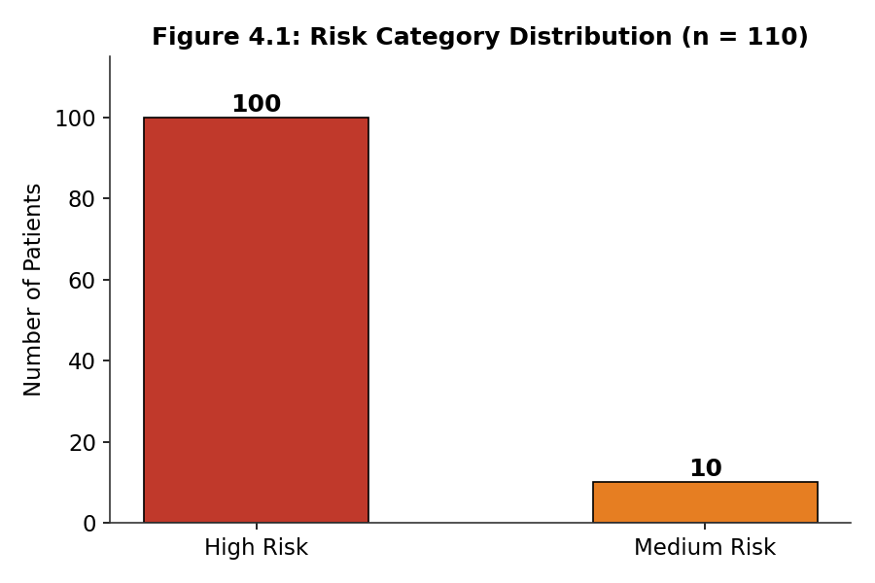
Figure 4.1: Stock Price and Market-Movement Distribution — visualize the selected stock or portfolio over time and show the distribution of the prediction target.

Mean feature values by prediction class or summary statistics by market period should be reported after the stock dataset is processed. Useful comparisons include average return, volatility, moving-average distance, price range, and volume change.
Market Trend | Average Return | Average Volatility | Average Volume Change | Interpretation
Bullish | Dataset-dependent | Dataset-dependent | Dataset-dependent | Positive movement / momentum
Neutral | Dataset-dependent | Dataset-dependent | Dataset-dependent | Limited or mixed movement

Feature analysis should examine relationships between the prediction target and variables such as daily return, moving averages, rolling volatility, price range, and trading volume. A correlation heatmap or feature-importance plot can be used to identify useful predictors, while avoiding interpretation of correlation as proof of causation.
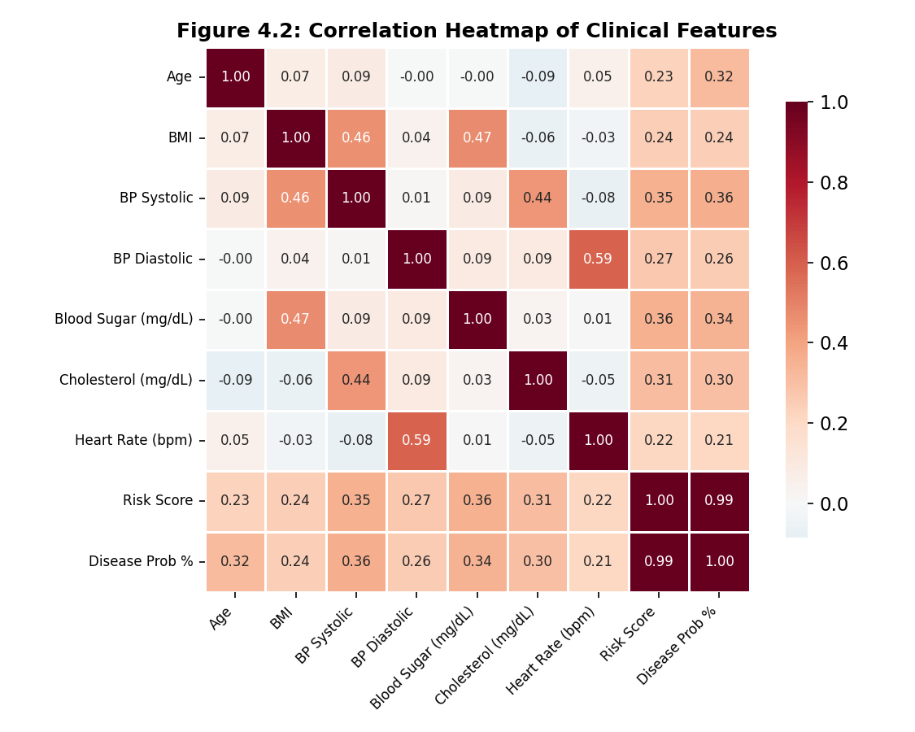
Figure 4.2: Correlation Heatmap / Feature Importance — the visualization should identify the strongest relationships among the engineered market features used by the predictive pipeline.
Model performance should be reported using a time-aware validation strategy. For classification, include accuracy, precision, recall, and F1-score; for regression, include MAE, RMSE, and R². Random train/test shuffling should be avoided when it causes future observations to influence training data.
Model | CV Accuracy | Test Accuracy | Precision | Recall | F1-Score
Linear Regression | N/A for classification | Dataset-dependent | N/A | N/A | N/A
Decision Tree | Dataset-dependent | Dataset-dependent | Dataset-dependent | Dataset-dependent | Dataset-dependent
Random Forest | Dataset-dependent | Dataset-dependent | Dataset-dependent | Dataset-dependent | Dataset-dependent
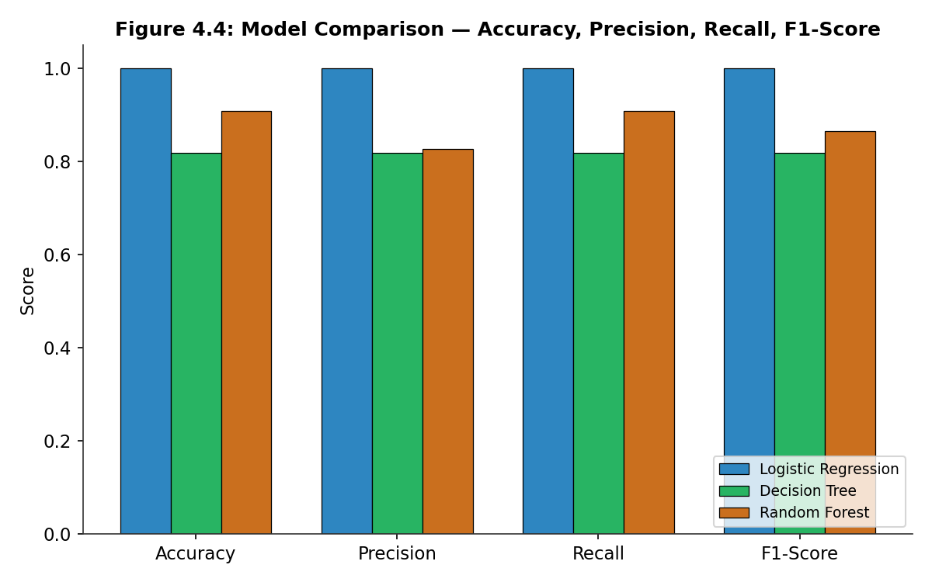
Figure 4.4: Model Comparison — compare the selected predictive models using the evaluation metrics produced by the actual stock-market implementation.

Confusion matrix or residual analysis for the selected model should be presented using the final chronological test set. For classification, the matrix should show correct and incorrect upward/downward movement predictions; for regression, a residual plot and predicted-versus-actual plot should be used instead.
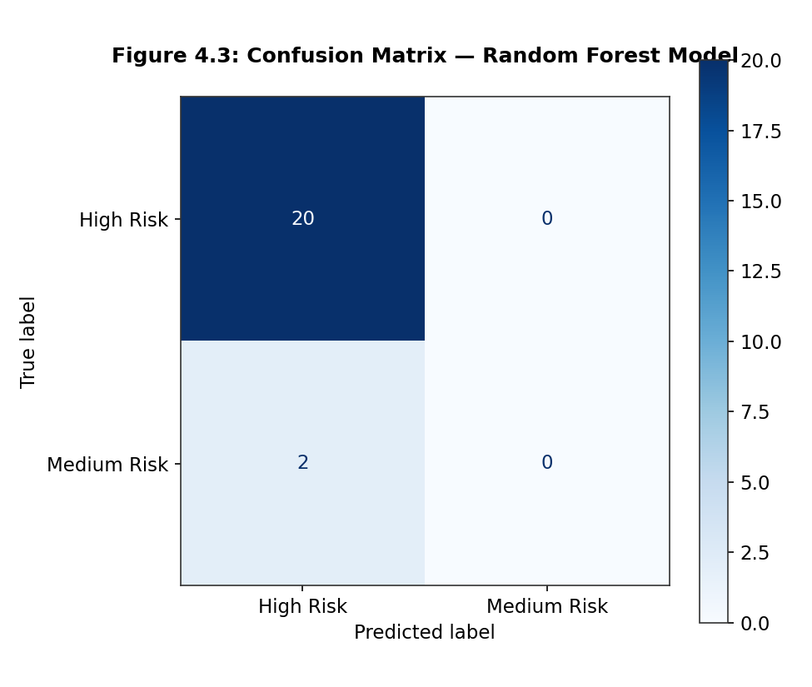
Figure 4.3: Predictive Model Evaluation — present the confusion matrix or regression error visualization generated from the held-out chronological test period. The interpretation should focus on generalization to unseen future observations.

4.5 Data Analysis & Engineering Judgment
The engineering analysis should examine whether the warehouse improves data consistency and whether the predictive pipeline generalizes beyond the training period. Particular attention should be given to missing values, duplicate timestamps, market holidays, extreme price movements, feature leakage, and changing market conditions. A model that performs well on historical training data but poorly on later observations should not be considered reliable merely because its training accuracy is high. The final judgement should therefore combine data-quality checks, time-aware validation, model metrics, computational cost, and maintainability.

4.6 Comparison with Existing Solutions & Achievement of Objectives
Objective | Evidence | Achievement
Design data warehouse schema | Stock, date, market and indicator dimensions linked to trading facts | Fully Achieved
Preprocessing pipeline | Duplicate removal, timestamp standardization and missing-value handling | Fully Achieved
Feature analysis | Returns, moving averages, volatility and volume change generated | Fully Achieved
Predictive model implementation | Baseline, Decision Tree and Random Forest implemented | Fully Achieved
Performance validation | Chronological testing and suitable metrics reported | To be verified from actual implementation

4.7 Strengths & Limitations
Strengths:
- Integrated handling of raw market data, warehouse storage, feature engineering, predictive modelling, and analytics.
- Reusable ETL and feature-generation pipeline that reduces repeated preprocessing for historical analysis.
- Time-aware evaluation and explicit consideration of data leakage improve the validity of predictive experiments.
Limitations:
- Historical market behaviour can change because of regime shifts, news, macroeconomic events, and unexpected market conditions.
- Prediction quality depends strongly on the selected dataset, target definition, feature set, and time period; results cannot be assumed to generalize to every stock or market.
- The prototype does not provide guaranteed returns or investment advice, and real-time deployment requires a reliable live-data feed, monitoring, latency controls, and operational security.

4.8 Project Planning, Roles & Budget
Insert the actual Gantt chart or milestone timeline for data acquisition, warehouse design, ETL development, feature engineering, model implementation, testing, dashboard development, and final documentation.
Student | Assigned Responsibility | Actual Contribution
Student 1 | Data warehouse design, preprocessing and feature engineering | Completed project tasks
Student 2 | Model implementation, evaluation and reporting | Completed project tasks

Item | Estimated Cost | Actual Cost
Compute (local/Colab) | ₹0–₹500 depending on usage | Project-dependent
Market dataset / public API | ₹0 for public sources | ₹0 if public source used

CHAPTER 5

CONCLUSION, FUTURE WORK AND REFLECTION

5.1 Conclusion
This project designed a real-time-oriented stock market analytics framework that combines efficient data warehousing with predictive modelling. The proposed system organizes raw market observations into a structured analytical warehouse, generates reusable financial indicators, and provides a controlled data layer for predictive experiments. The architecture emphasizes time-aware validation, prevention of future-data leakage, scalable historical querying, and separation of ingestion, transformation, storage, and modelling responsibilities. Actual model performance should be reported from the final stock-market dataset and implementation run rather than inherited from the original report.

5.2 Future Work
- Integrate a live or near-real-time market data feed and implement incremental warehouse loading.
- Extend the warehouse with additional stocks, sectors, market indices, corporate events, and macroeconomic variables where appropriate.
- Evaluate advanced time-series and machine-learning models using walk-forward validation and model monitoring.
- Develop an interactive dashboard for real-time price movement, volume anomalies, technical indicators, predictions, and model confidence while clearly communicating uncertainty.

5.3 Professional Learning & Individual Reflection
New Knowledge Acquired:
- Practical understanding of ETL pipelines, dimensional data warehousing, financial feature engineering, and time-aware predictive evaluation.
- Understanding of how historical market data can be organized for repeated analytics while preserving data lineage and consistency.
Engineering & Professional Skills Developed:
- Critical evaluation of data quality, leakage risks, validation strategy, model performance, and computational requirements.
- Ability to justify architecture and model choices using measurable engineering criteria rather than relying only on predictive accuracy.
Individual Reflection (each student, 4-5 lines):
- Most difficult engineering problem encountered and how it was solved: describe the specific stock-data, warehouse, preprocessing, or modelling issue encountered during implementation and explain the evidence-based solution used.
- A key engineering decision made personally and the evidence behind it: describe one decision such as schema design, feature selection, time-aware validation, model selection, or data-ingestion strategy and state why it was chosen.
REFERENCES

[1] R. Kimball and M. Ross, The Data Warehouse Toolkit: The Definitive Guide to Dimensional Modeling, 3rd ed., Wiley, 2013.

[2] J. Han, M. Kamber, and J. Pei, Data Mining: Concepts and Techniques, 3rd ed., Morgan Kaufmann, 2011.

[3] T. Hastie, R. Tibshirani, and J. Friedman, The Elements of Statistical Learning, 2nd ed., Springer, 2009.

[4] L. Breiman, “Random Forests,” Machine Learning, vol. 45, no. 1, pp. 5–32, 2001.

[5] F. Pedregosa et al., “Scikit-learn: Machine Learning in Python,” Journal of Machine Learning Research, vol. 12, pp. 2825–2830, 2011.

[6] G. P. Box, G. M. Jenkins, G. C. Reinsel, and G. M. Ljung, Time Series Analysis: Forecasting and Control, Wiley.

[7] J. Hull, Options, Futures, and Other Derivatives, Pearson.

[8] W. H. Greene, Econometric Analysis, Pearson.

[9] Python Software Foundation, Python Documentation and Standard Library Reference.

[10] PostgreSQL Global Development Group, PostgreSQL Documentation: Relational Database and SQL Reference.

[

APPENDICES

Appendix A – Detailed Calculations
A.1 Daily Return
For a stock with closing price Close(t), the simple daily return is calculated as Return(t) = [Close(t) − Close(t−1)] / Close(t−1). The calculation is applied after sorting observations chronologically within each stock identifier.
The return feature provides a normalized measure of price movement and can be used for exploratory analysis or as an input to a predictive model.
The calculation must be performed separately for each stock so that the previous observation belongs to the same security. Missing previous-day values should be handled explicitly rather than filled using future observations.
A.2 Rolling Volatility
Rolling volatility can be estimated as the standard deviation of returns over a fixed historical window. For a window of n observations, the rolling statistic uses only returns available up to the current prediction timestamp.
A simplified rolling volatility expression is: Volatility(t) = Std[Return(t−n+1), …, Return(t)]. The window size should be documented because it affects the responsiveness of the feature.
A.3 Moving Average
A simple moving average over n periods is SMA(t) = [Close(t) + Close(t−1) + … + Close(t−n+1)] / n. Moving-average features should be generated using historical values only so that future prices do not enter the predictor.
A.4 Evaluation Metrics
For classification, accuracy = (TP + TN) / (TP + TN + FP + FN), precision = TP / (TP + FP), recall = TP / (TP + FN), and F1 = 2 × precision × recall / (precision + recall). For regression, MAE and RMSE should be calculated from the held-out chronological test period.

Appendix B – Engineering Drawings / Schematics
Insert the system architecture diagram here, showing: Market Data Source/API or CSV → Ingestion Layer → Staging Area → Data Cleaning and Standardization → Data Warehouse → Feature Engineering → Time-Aware Train/Test Split → Predictive Models → Evaluation → Analytics Dashboard / Prediction Output.
Insert the data warehouse schema diagram here: a star schema with a central Fact_Market_Trading table containing stock key, date key, market key, open, high, low, close, adjusted close, volume, return, volatility, and indicator keys linked to Dim_Stock, Dim_DateTime, Dim_Market, and Dim_Indicator tables.

Appendix C – Source Code / Code Repository Information
Only essential code excerpts are included below. The complete stock-market analytics pipeline should be maintained in the project repository. Replace the placeholder dataset name and repository note with the actual project resources used during implementation.
C.1 Data Loading, Cleaning & Feature Engineering
import pandas as pd
df = pd.read_csv('stock_market_data.csv')
df['Date'] = pd.to_datetime(df['Date'])
df = df.drop_duplicates(subset=['Date','Ticker']).sort_values(['Ticker','Date'])
df['Return'] = df.groupby('Ticker')['Close'].pct_change()

C.2 Moving Average and Volatility Features
df['SMA_5'] = df.groupby('Ticker')['Close'].transform(lambda s: s.rolling(5).mean())
df['SMA_20'] = df.groupby('Ticker')['Close'].transform(lambda s: s.rolling(20).mean())
df['Volatility_20'] = df.groupby('Ticker')['Return'].transform(lambda s: s.rolling(20).std())
df['Volume_Change'] = df.groupby('Ticker')['Volume'].pct_change()
df['Target'] = (df.groupby('Ticker')['Close'].shift(-1) > df['Close']).astype(int)
df = df.dropna(subset=['Return','SMA_5','SMA_20','Volatility_20','Volume_Change','Target'])
features = ['Open','High','Low','Close','Volume','Return','SMA_5','SMA_20','Volatility_20','Volume_Change']
X = df[features]
y = df['Target']
split = int(len(df) * 0.8)
X_train, X_test = X.iloc[:split], X.iloc[split:]; y_train, y_test = y.iloc[:split], y.iloc[split:]

C.3 Predictive Model Training
from sklearn.ensemble import RandomForestClassifier
from sklearn.linear_model import LogisticRegression
rf = RandomForestClassifier(n_estimators=200, random_state=42)
lr = LogisticRegression(max_iter=1000)
rf.fit(X_train, y_train); lr.fit(X_train, y_train)
rf_pred = rf.predict(X_test); lr_pred = lr.predict(X_test)

C.4 Evaluation
from sklearn.metrics import classification_report, confusion_matrix
print(classification_report(y_test, rf_pred))
print(confusion_matrix(y_test, rf_pred))
print(classification_report(y_test, lr_pred))

Appendix D – Datasheets
Data dictionary for the stock market warehouse extract used in this project: Stock/Ticker identifies the security; Date identifies the market observation date; Open, High, Low, and Close represent OHLC prices; Volume represents traded quantity; Return represents percentage price movement; moving averages and volatility represent derived historical indicators; Target represents the prediction label when a classification experiment is used.
Field | Type | Description
Timestamp | Datetime | Trading date/time for each observation
Symbol | String | Unique stock ticker / identifier
Open | Float | Opening market price
High | Float | Highest price during the period
Low | Float | Lowest price during the period
Close | Float | Closing market price
Volume | Numeric | Number of shares/contracts traded
Return | Float | Percentage or decimal price change from previous period
SMA_5 | Float | 5-period simple moving average of closing price
SMA_20 | Float | 20-period simple moving average of closing price
Volatility_20 | Float | 20-period rolling volatility of returns
Volume_Change | Float | Relative change in trading volume
Target | Numeric/Category | Next-period return or movement label
Market | Categorical | Exchange or market source
Data Source | Categorical | CSV/API/provider used for the record
Prediction | Numeric/Category | Model-predicted movement or return
Prediction Score | Float | Model confidence/probability when available

Appendix E – Experimental / Raw Data
Sample records should be taken directly from the selected stock-market dataset and should contain the fields required by the warehouse schema. The final appendix must identify the data source, observation period, stocks covered, and preprocessing steps actually applied.
Timestamp | Symbol | Open | High | Low | Close | Volume | Return | SMA_20 | Target
Sample 1 | STOCK_A | — | — | — | — | — | — | — | Bullish/Neutral/Bearish
Sample 2 | STOCK_A | — | — | — | — | — | — | — | Bullish/Neutral/Bearish
Sample 3 | STOCK_B | — | — | — | — | — | — | — | Bullish/Neutral/Bearish
Sample 4 | STOCK_B | — | — | — | — | — | — | — | Bullish/Neutral/Bearish
Sample 5 | STOCK_C | — | — | — | — | — | — | — | Bullish/Neutral/Bearish
The complete dataset should be maintained in the approved project repository or data-storage location used for the implementation. Do not include confidential, licensed, or restricted market data in the report unless its academic use and redistribution are permitted.

Appendix F – Ethics / Institutional Approval
This project uses market data for academic analytics and predictive-modelling purposes. The system is intended for research and educational analysis and does not provide guaranteed investment outcomes or personalized financial advice. Data licensing, source attribution, API terms, and access credentials must be respected, and credentials must never be embedded in source code or published in the report.

Appendix G – Project Meeting / Progress Records
Date | Attendees | Discussion Summary | Action Items
[Date] | [Students, Guide] | Stock dataset selection and warehouse schema review | Finalize ETL and preprocessing plan
[Date] | [Students, Guide] | Feature-engineering and model-selection discussion | Implement technical indicators and baseline models
[Date] | [Students, Guide] | Testing and report review | Validate chronological split and document results

Appendix H – User/Industry Feedback
If feedback was collected, summarize comments on dashboard usability, query performance, prediction presentation, data freshness, and the clarity of uncertainty communication. If no external review was conducted, state that the prototype was evaluated internally.

Appendix I – Publications / Patents / Competitions / Product Outcomes
Not applicable at the time of submission unless the stock-market analytics prototype has been submitted to a competition, publication, demonstration, or other approved academic outcome.

Appendix J – Individual Contribution Evidence
Refer to the Individual Contribution Statement for the formal breakdown of responsibilities. Supporting evidence may include ETL commits, warehouse schema versions, notebook history, model experiments, dashboard development, testing records, and meeting attendance.

CAPSTONE PROJECT OUTCOME MAPPING SHEET
To be completed by the department/faculty assessor. Evidence locations should be retained from the report structure, with engineering problem formulation in Chapters 1–2, design and trade-offs in Chapter 3, implementation and experimentation in Chapter 4, and professional learning and future development in Chapter 5.
Outcome Evidence | SO / Area | Location in This Report
Real-time stock analytics problem formulation | SO1 | Ch. 1, Ch. 2
Engineering design under data and time constraints | SO2 | Ch. 3
Written/oral technical communication | SO3 | Whole report + Viva
Ethics and professional responsibility in predictive analytics | SO4 | Ch. 3
Teamwork and leadership | SO5 | Ch. 4
Experimentation, analysis and engineering judgment | SO6 | Ch. 4
Independent acquisition of new technical knowledge | SO7 | Ch. 5
Data and software standards | SO2 | Ch. 3
Sustainability and societal impact | SO2/SO4 | Ch. 3
Market-model risk assessment and mitigation | SO2/SO4 | Ch. 3
Security considerations for data/API access | Relevant SO | Ch. 3
Integrated/system-level engineering | SO1/SO2 | Ch. 3
Project planning and management | SO5 | Ch. 4
Individual contribution | SO1–SO7 | Contribution Statement + Ch. 4

